|  |
| --- |
| **Flyaway** |
| (Project Screenshots) |

**Version History:**

|  |  |
| --- | --- |
| Author | KUMAR ABHISHEK |
| Purpose | Screenshots of the application |
| Date | 06 OCTOBER 2021 |
| Version | 1.0 |

Contents

**1 . Home: 3**

**2.Admin login page: 4**

**3. Admin Dashboard: 5**

**4. Change password: 6**

**5. Change password sucess: 7**

**6. see all flights and Registration : 8**

**7.payment page: 10**

**8. payment successful page: 11**

# 1. Home:

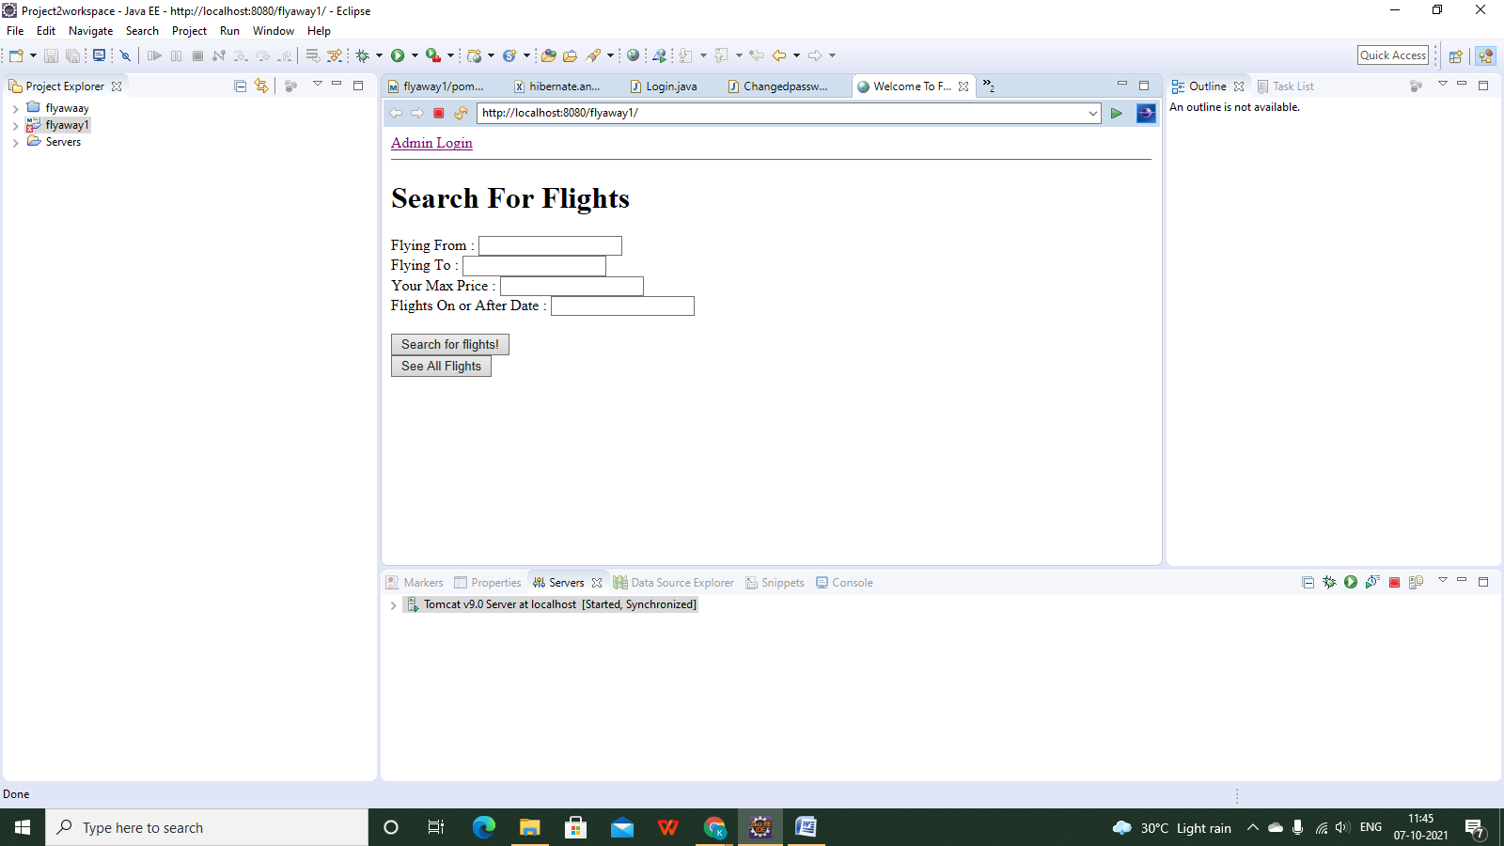

# 2. Admin login page:

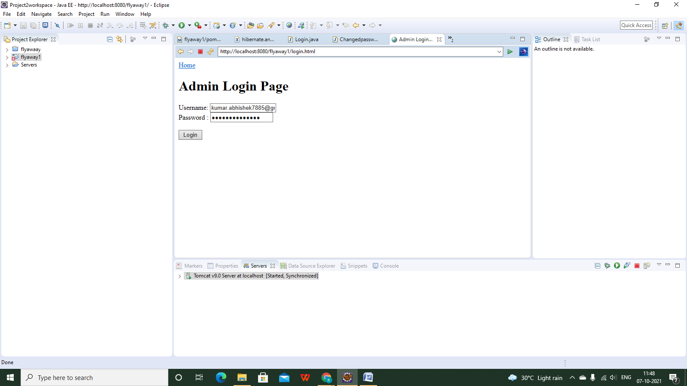

# 3. Admin Dashboard:

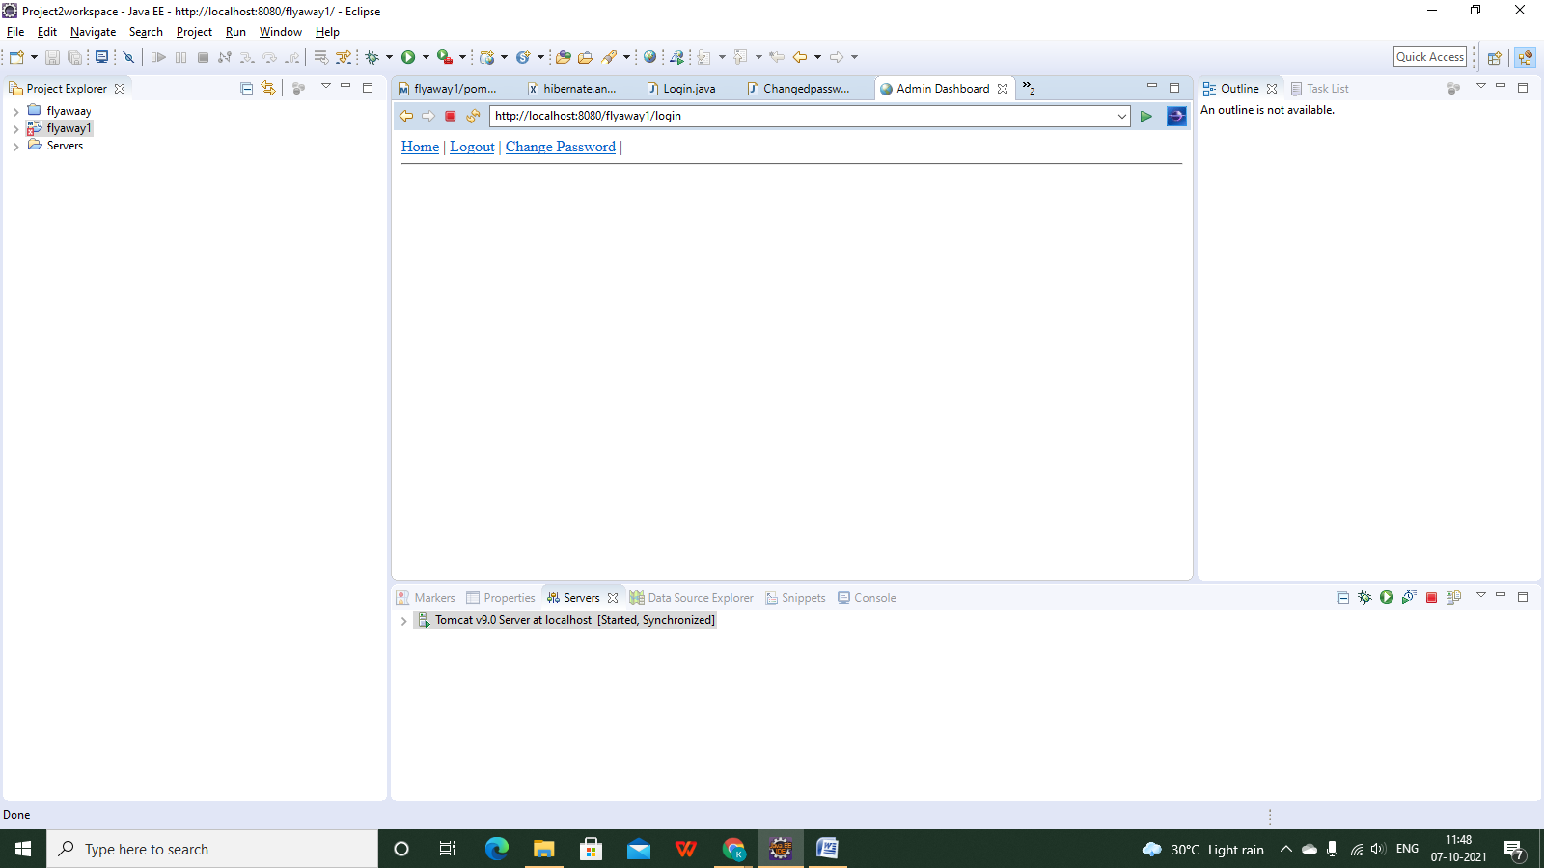

# 4. Change password:

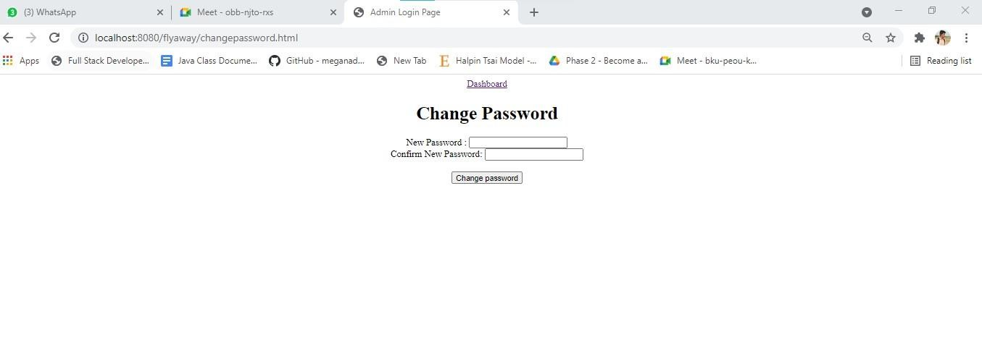

# 5. Change password success:

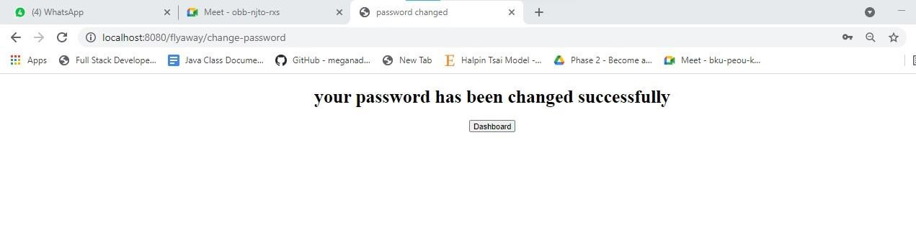

# 6. See all flights and Registration:

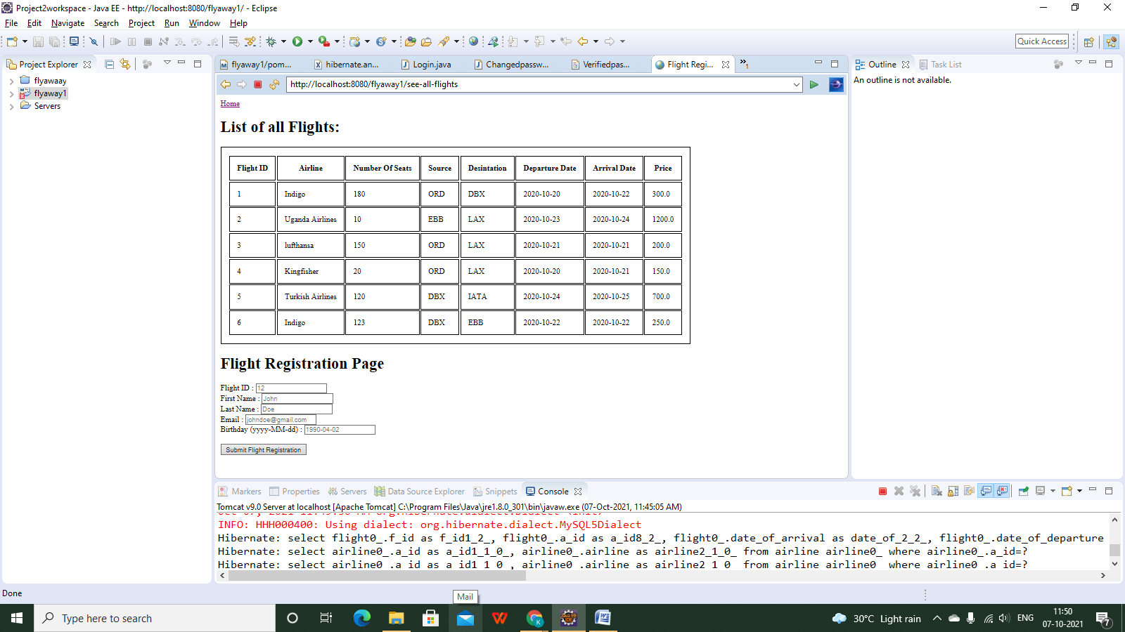

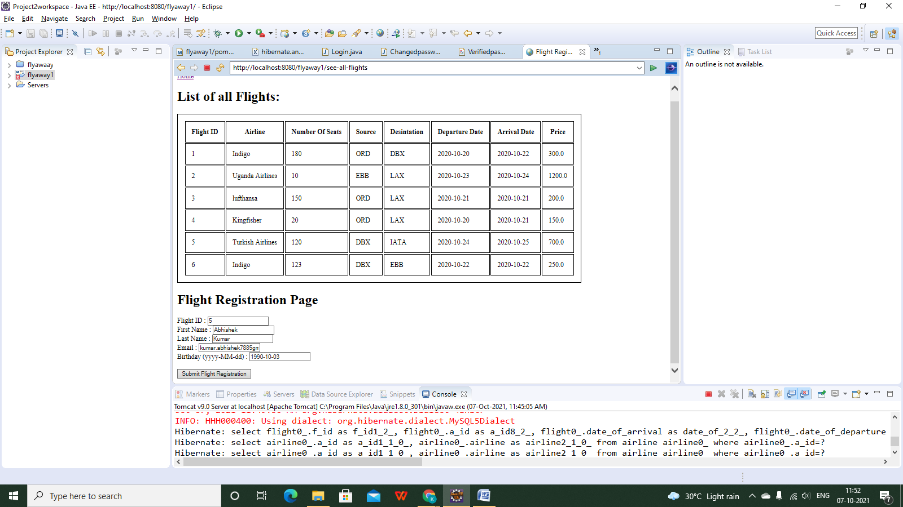

# 7.payment page:

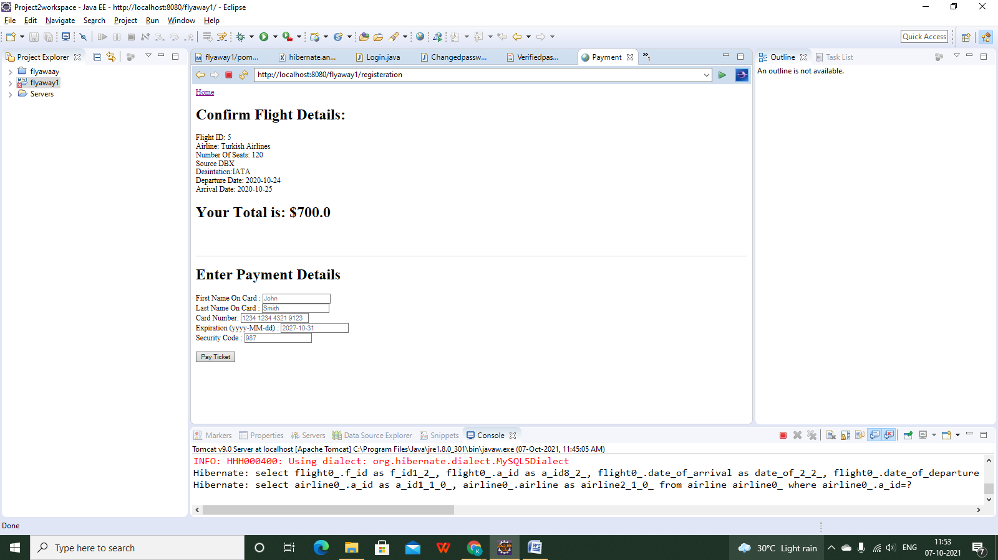

# 8. Payment successful page:

